# CS 255 System Design Document

## UML Diagrams

### UML Use Case Diagram

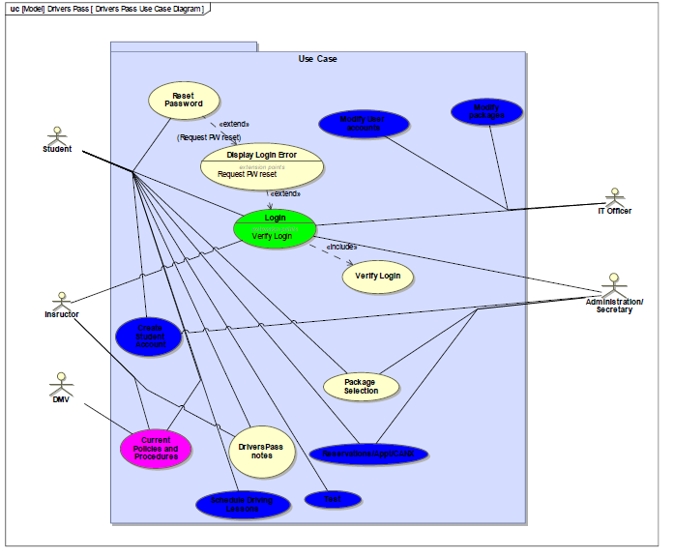

### UML Activity Diagrams

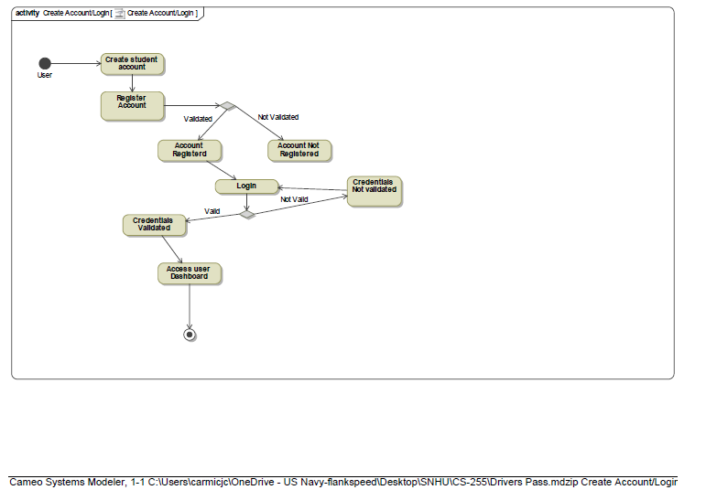

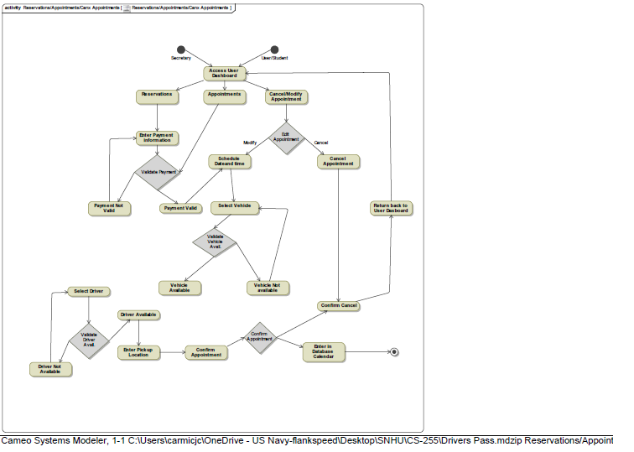

### UML Sequence Diagram

### UML Class Diagram

## Technical Requirements

*DriversPass is a website that will perform across all platforms. Today’s requirements will be tailored to desktop applications but will also address to be suitable to mobile applications. Since DriversPass is a company that will be on the road, having a mobile platform that will be easy to use, it will require a layout to adapt to the screen size of the user. DriversPass will have third party integrations. Links provided from DMV to review and update the policies and procedures. If DMV changes the link and DriversPass is not available, steps will be provided for the IT officer to update the link to prevent any downtime. DriversPass will start off with a registered domain. Since all data and files will be stored off site, it will be stored via Google Drive enterprise. Google Drive is a secure cloud service that can store all required information. Driverspass will require minimum storage requirements due to the amount of data. There will be a XML sitemap that will be enabled so search engines can detect DriversPass easier. Website security and firewall. Your website will adopt all security practices, and usernames and passwords will require unique names with 15 alpha numeric passwords. DriversPass will use Transport Layer Security (TLS) security to keep the website safe and protect the data.*